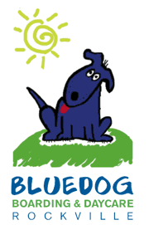

“I can’t wait to spend the night at BlueDog! Where am I going to sleep?”

*4101 Howard Avenue, Kensington, MD 20895*

***Tel:*** *(301) 217-0010* ***Fax:*** *(301) 217-0090*

*Find us online: www.dogboarding.net*

*Open* ***6am-9pm*** *everyday!*

***Owner:*** *Janet Sidebottom*